**Data warehouse concepts**

**Data warehouse schemas**

<https://youtu.be/boXpd6Q_9Kk>

**Kimball's vs Inmon's methodologies**

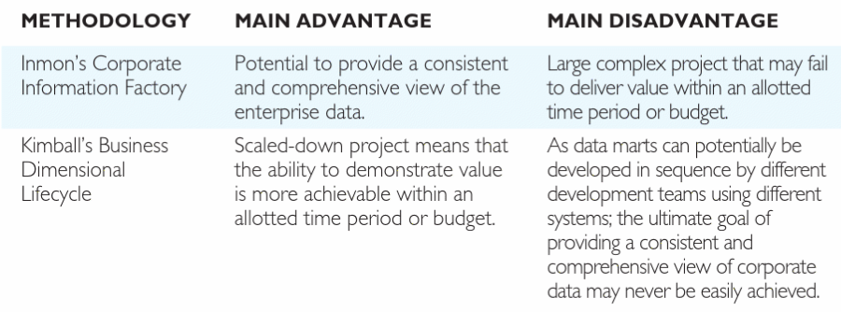For more details on the two data warehouse approaches and some interesting infographics please visit [here](https://www.educba.com/kimball-vs-inmon/).  
 **Compare Enterprise data warehouse to data mart**

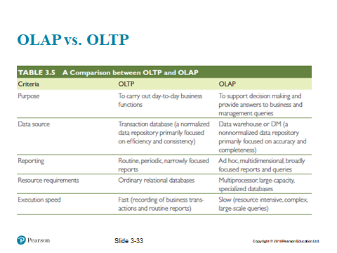

**Normalisation overview**

* Normalisation is the process of ensuring that data in tables only relates to the records stored in that table.
* Some attributes might better in a table of their own.

**T-SQL queries**

<https://youtu.be/1qLa8ZdP4FA>

**Common BI dimensionality concepts**

<https://youtu.be/-wGk2B4OqJg>

**Further reading / extension activity**

Connolly, T., & Begg, C. E. (2015). *Database systems. [electronic resource] : a practical approach to design, implementation, and management* (6th ed. Global ed.). Pearson. Chapters 31 & 32

**Data warehouse concepts**

<https://youtu.be/zTs5zjSXnvs>

**Kimball model**

<https://youtu.be/lWPiSZf7-uQ>